Technology Stack

|  |  |
| --- | --- |
| Date | 20 October 2022 |
| Team ID | PNT2022TMID28249 |
| Project Name | University Admit Eligibility Predictor |
| Maximum Marks | 4 Marks |

Technical Architecture:

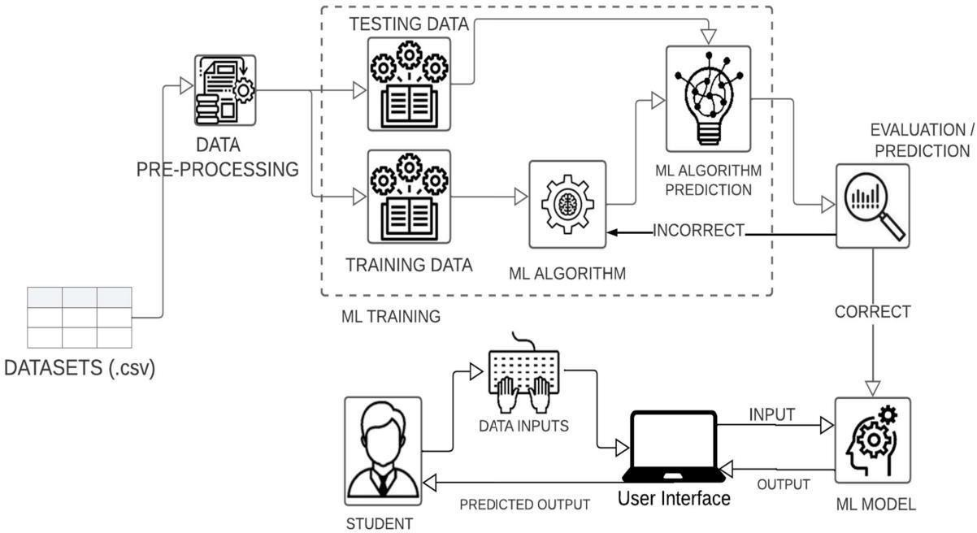

Components & Technologies:

|  |  |  |  |
| --- | --- | --- | --- |
| **S.No** | **Component** | **Description** | **Technology** |
| 1. | User Interface | Web Application | Flutter |
| 2. | Application Logic | By collecting and analyzing the datasets and other relevant details to help in training the model to predicts at maximum accuracy. | Machine learning using Python |
| 3. | Database | To store and retrieval of necessary data. | MySQL, etc. |
| 4. | Cloud Database | Database Service on Cloud | IBM DB2, IBM Cloudant etc. |
| 5. | File Storage | File storage requirements | IBM Block Storage or Other Storage Service or Local Filesystem |
| 6. | Machine Learning Model | Regression models are used to target a prediction value which is based on independent variables. It is also used to calculate the relationship between any two quantitative variables.  Classifiers also predict the target output based on various features. | Linear regression, Random forest, etc. |
| 7. | Infrastructure (Server / Cloud) | Application Deployment on Local System/Cloud Server. Local Server: HTTP Server Cloud Server: IaaS, SaaS | Local, Cloud Foundry, Kubernetes, etc. |

Application Characteristics:

|  |  |  |  |
| --- | --- | --- | --- |
| **S.No** | **Characteristics** | **Description** | **Technology** |
| 1. | Open-Source Frameworks | Flutter, apache, native script, etc. | Flutter |
| 2. | Security Implementations | Store private data within internal storage, ensure  different access levels to different users. | Web view objects,  debug- override, etc. |
| 3. | Scalable Architecture | 3 – tier, Micro-services | REST API |